**Name: Sushant Tulasi Class: D15B**

**Roll: 64**

**Adv DevOps Assignment 1** Aim: **To develop a website and host it on your local machine on a VM** Theory:

To develop and host a website on your local machine using XAMPP and a virtual machine (VM), here are

the theoretical steps and implementation details:

# Understanding the Basics

* + **Website Development**: This involves writing code (HTML, CSS, JavaScript, PHP, etc.) for the front-end and back-end (if applicable). For example, HTML for structure, CSS for styling, JavaScript for functionality, and PHP for server-side scripting.
  + **Local Hosting**: XAMPP is a free and open-source cross-platform web server solution stack package developed by Apache Friends, consisting mainly of Apache HTTP Server, MySQL database, and interpreters for scripts written in PHP and Perl.
  + **VM Setup**: You can use software like VirtualBox or VMware to create a virtual machine with an operating system to host your development environment.

To develop and host a website on your local machine using XAMPP and a virtual machine (VM), here are the theoretical steps and implementation details:

# Understanding the Basics

* + **Website Development**: This involves writing code (HTML, CSS, JavaScript, PHP, etc.) for the front-end and back-end (if applicable). For example, HTML for structure, CSS for styling, JavaScript for functionality, and PHP for server-side scripting.
  + **Local Hosting**: XAMPP is a free and open-source cross-platform web server solution stack package developed by Apache Friends, consisting mainly of Apache HTTP Server, MySQL database, and interpreters for scripts written in PHP and Perl.
  + **VM Setup**: You can use software like VirtualBox or VMware to create a virtual machine with an operating system to host your development environment.

# Installing XAMPP on the Virtual Machine

XAMPP includes Apache, MySQL (MariaDB), and PHP/Perl, which are essential for running a local server.

**Steps:**

1. **Download XAMPP**:
   * Visit Apache Friends and download XAMPP for the OS installed on your VM.
2. **Install XAMPP**:
   * Open the downloaded ﬁle and follow the installation instructions.
   * Install Apache, MySQL, and PHP components.
3. **Start XAMPP Services**:
   * Open the XAMPP Control Panel.
   * Start **Apache** (Web Server) and **MySQL** (Database) services.

# Website Development

**Steps:**

* 1. **Website Files**:
     + Place your website ﬁles (HTML, CSS, JS, PHP) in the htdocs folder located in the XAMPP installation directory (e.g., /opt/lampp/htdocs/ on Linux or C:\xampp\htdocs\ on Windows).
  2. **Database Setup** (Optional):
     + If your website requires a database, you can set it up using **phpMyAdmin**, which is bundled with XAMPP.
     + Open your browser and visit <http://localhost/phpmyadmin>to access the MySQL database management interface.
     + Create a new database and import/export tables if necessary.

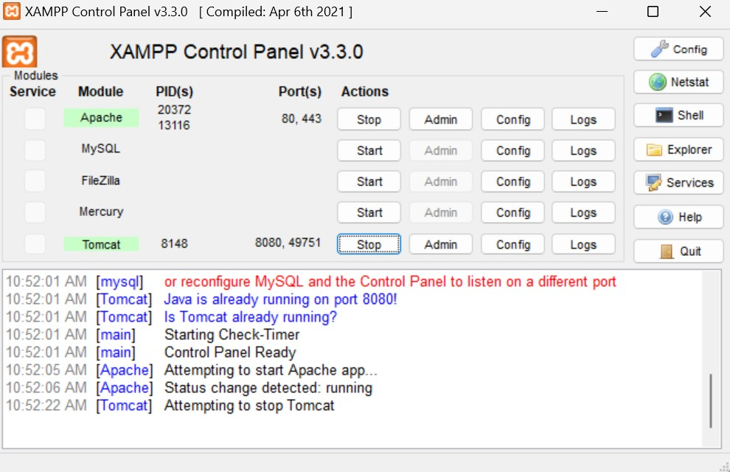

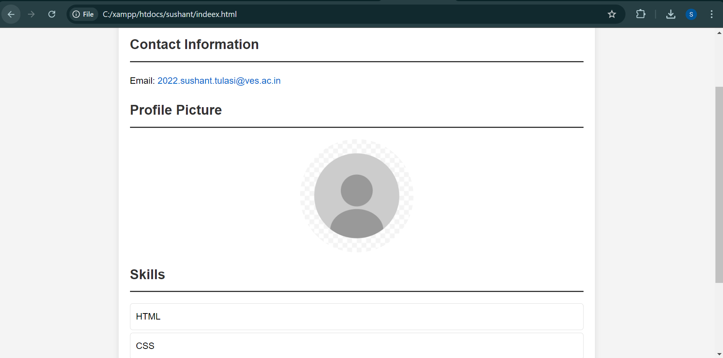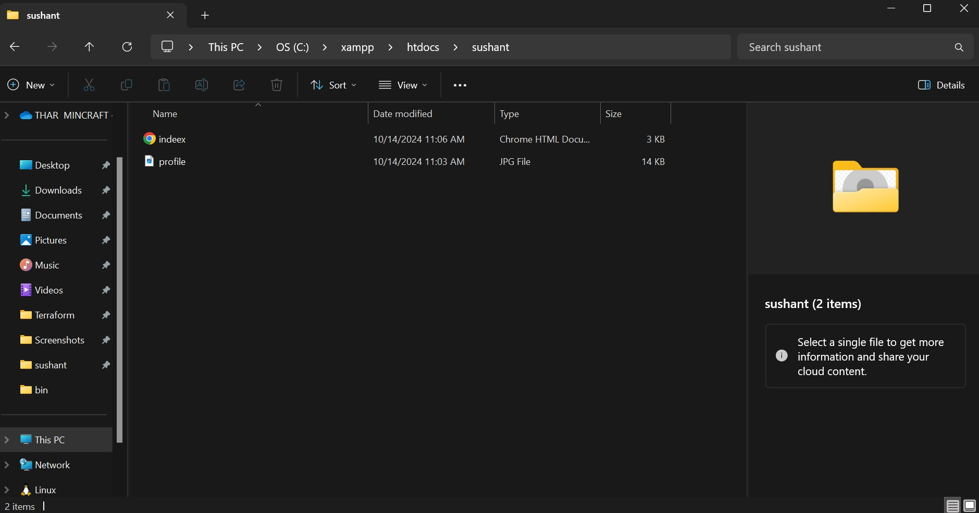2)

# Uploading a Website on AWS S3 Bucket: Theory and Steps

Amazon S3 (Simple Storage Service) is a cloud storage service that can host static websites. Unlike local hosting (e.g., with XAMPP), AWS S3 is used for deploying websites on the cloud, making them globally accessible. Here's the theory and the steps involved in uploading and hosting a website using an S3 bucket.

# Understanding the Basics

* + Static Website Hosting: Amazon S3 can only host static websites, meaning the website contains ﬁles like HTML, CSS, JavaScript, and images. It doesn’t support server-side scripting (PHP, Python, etc.).
  + Cloud Hosting: Using AWS S3, your website ﬁles are stored in a cloud bucket, and they can be accessed via a unique URL assigned to the bucket

lobal Accessibility: Once hosted on S3, your website is accessible globally, making it suitable for users who need fast and reliable hosting.

# Setting Up AWS S3

To host a website on S3, you'll need to create an S3 bucket and conﬁgure it for static website hosting.

Steps:

1. Create an AWS Account:
   * Sign up at [aws.amazon.com](https://aws.amazon.com/).
2. Access S3 Service:
   * Log in to the AWS Management Console.
   * Search for "S3" in the services search bar and open the Amazon S3 dashboard.

# Create an S3 Bucket

**Steps:**

1. Create a New Bucket:
   * Click on Create Bucket.
   * Enter a unique bucket name (this name will form part of the website URL).
   * Select a region (preferably close to your target audience).
   * Uncheck the "Block all public access" option, as this is required to make the website publicly accessible.
   * Conﬁrm by clicking Create Bucket.

# Upload Your Website Files

**Steps:**

1. Upload Static Files:
   * Click on the newly created bucket name.
   * Click Upload and add all your static website ﬁles (HTML, CSS, JavaScript, images).
   * Once the ﬁles are added, click Upload to ﬁnish the process.
2. Set Permissions:
   * To make your ﬁles publicly accessible, you need to conﬁgure the permissions:
     + Select the ﬁles you uploaded.
     + Click on Actions > Make public

# Conﬁgure Static Website Hosting

**Steps:**

1. Enable Static Website Hosting:
   * In the S3 bucket, go to the Properties tab.
   * Scroll down to Static Website Hosting.
   * Select Enable.

* Enter the name of your index document (usually index.html), and optionally an error document (like 404.html).

1. Save the Changes:

* Save the conﬁguration. Once saved, AWS S3 will generate a website endpoint URL (e.g.,

[http://your-bucket-name.s3-website-region.amazonaw](http://your-bucket-name.s3-website-region.amazonaw/) s.com).

# Testing the Website

* + Open the website endpoint URL that was generated when you enabled static website hosting.
  + Your website should be live, and you can access it from any browser using the URL.

# Conﬁgure Bucket Policy for Public Access

If you get an error when accessing your site, you may need to adjust the bucket policy to allow public access to your ﬁles.

Steps:

1. Go to Permissions:
   * In the bucket, navigate to the Permissions tab.
2. Add a Bucket Policy:
   * Click Bucket Policy and add the following JSON policy to allow public access:

json

Copy code

{

"Version": "2012-10-17",

"Statement": [

{

"Sid": "PublicReadGetObject", "Effect": "Allow",

"Principal": "*", "Action": "s3:GetObject",

"Resource": "arn:aws:s3:::your-bucket-name/*"

}

]

}

3.

* Replace your-bucket-name with the actual bucket name.
* Save the policy.

# Optional: Custom Domain and SSL

If you want to use a custom domain for your website, you can do the following:

* + Custom Domain: Use Amazon Route 53 or your own DNS provider to map your domain to the S3 website.
  + SSL/TLS Encryption: You can use Amazon CloudFront (AWS’s CDN service) to add SSL/TLS support and improve performance by serving content from global edge locations.

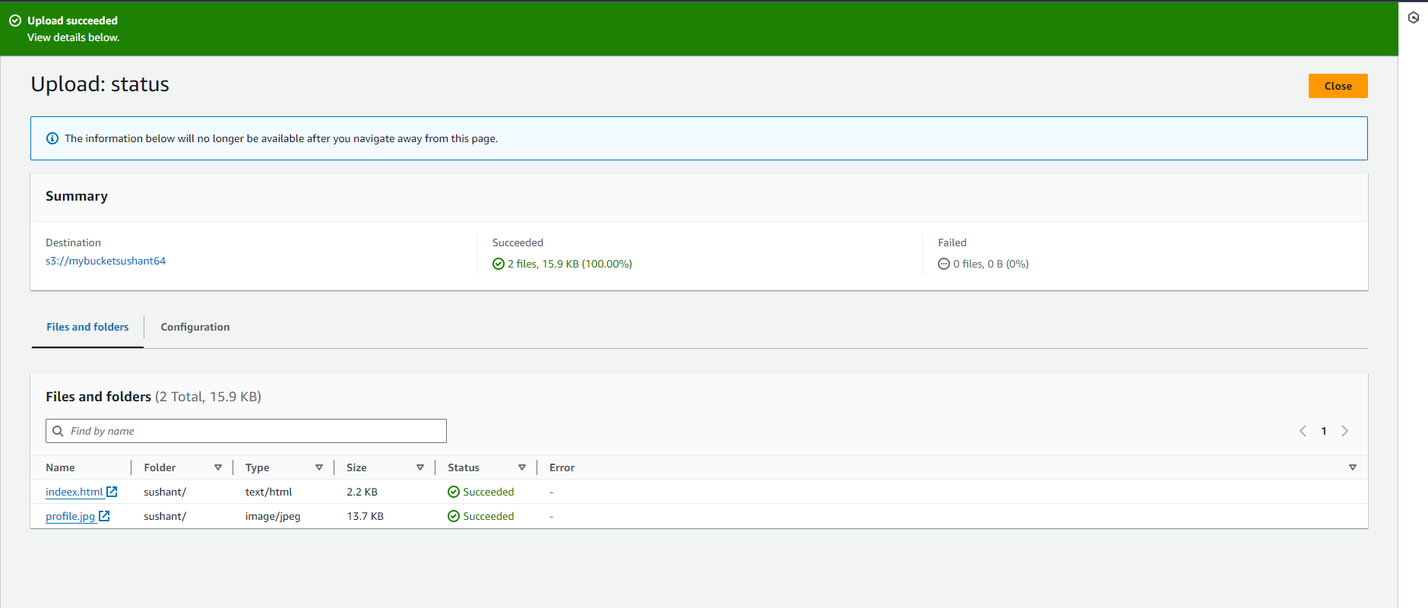

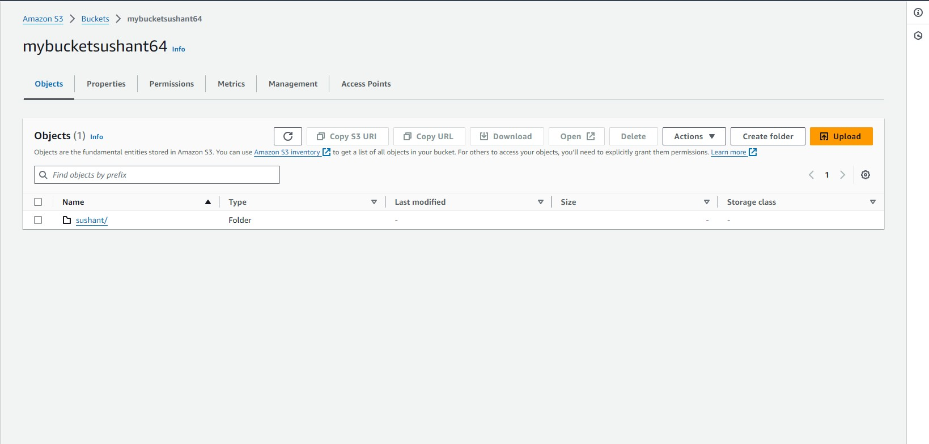

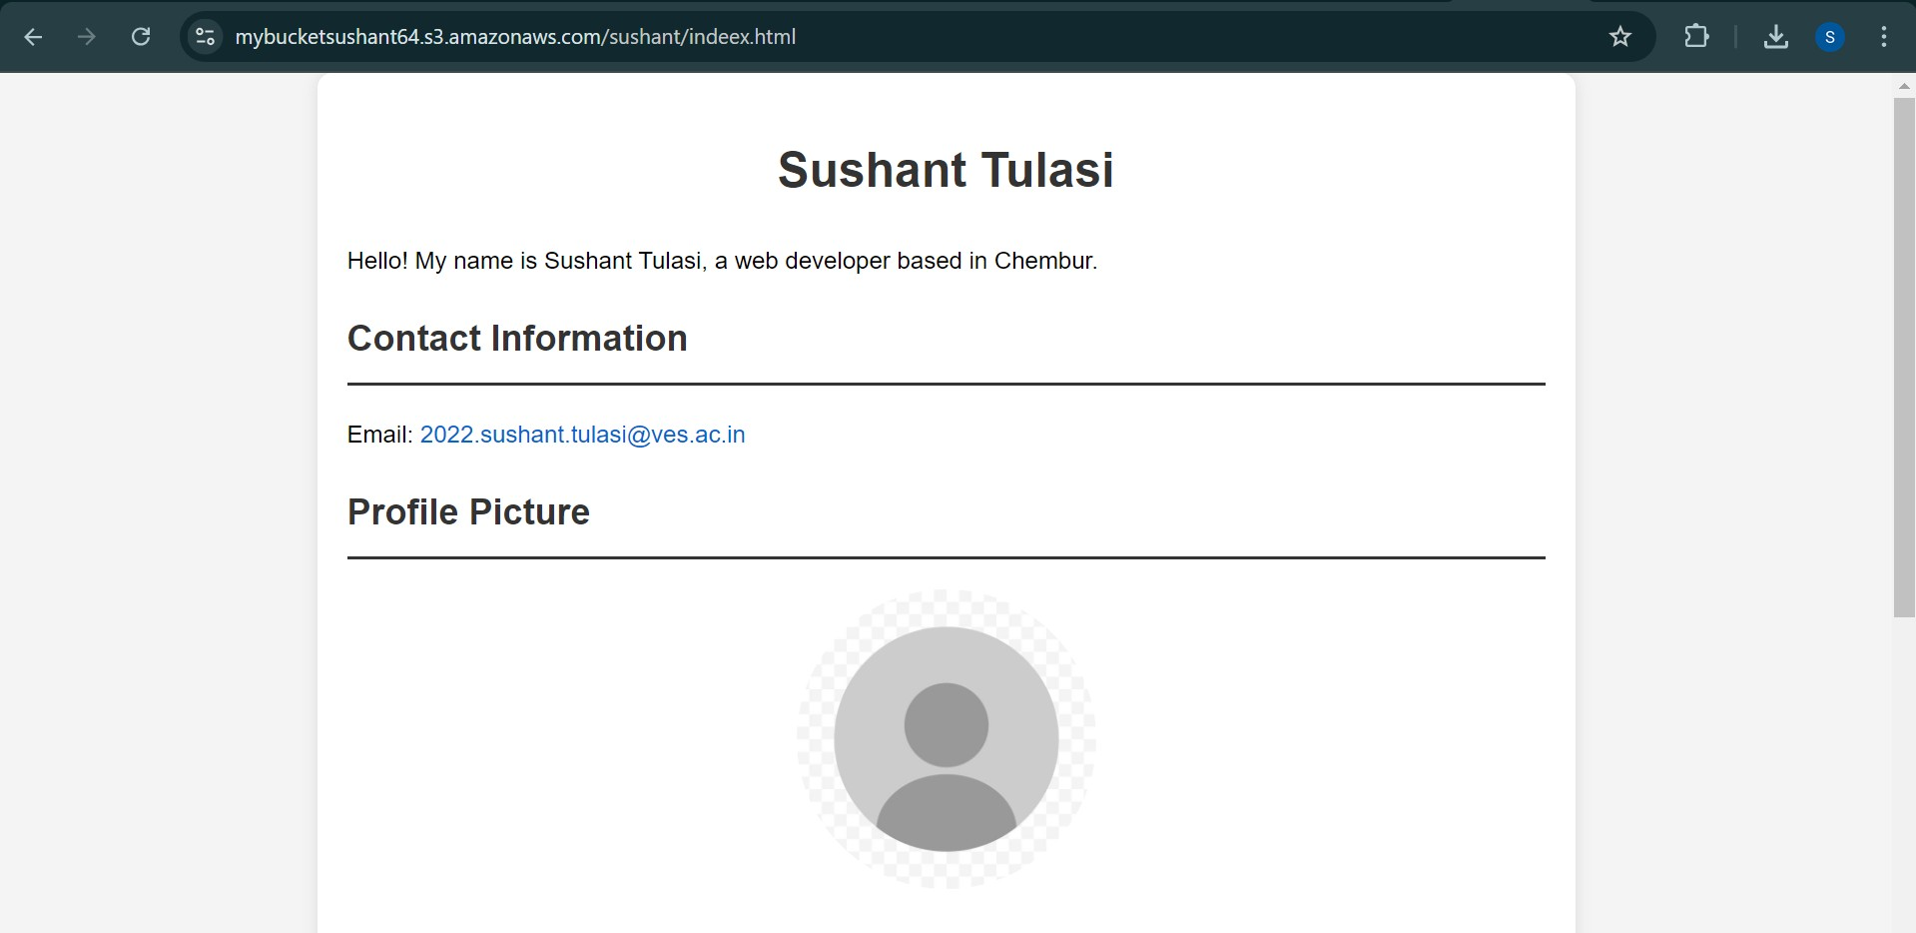

# Conclusion

Developing and hosting a website on your local machine using a virtual machine (VM) and XAMPP offers a powerful, ﬂexible environment for web development. The process involves setting up a VM, installing XAMPP to manage your web server (Apache), database (MySQL), and scripting languages (PHP/Perl), and then developing your website within the XAMPP environment. With the ability to simulate a real-world hosting setup on your local machine, you can test and debug the website eﬃciently before deploying it to production. This method ensures a well-organized and isolated development environment, making it ideal for web developers seeking to create, test, and reﬁne their projects.